

Customer Portal – Functional Requirement and Conceptual Design

Projects | USME – Ascent Rental Salesforce CRM Implementation
Prepared For | USME
Document Status | Issued

Document Change Control Log:
The Document Change Control Log is updated each time the document is modified. The log identifies the version number, the date of revisions, a brief description of the changes, and the author/reviewer
Version # | Date | Description | Author
V1.0 |  | Integration Requirements | Durvah

Approvals from USME Team:
Version # | Date | Approver Role | Approver

Purpose
This document specifies what the integration between GoTransverse (GT) and Acumatica must do for USME: invoices going from GT to Acumatica for revenue recognition and AR, and payments coming back from Acumatica to GT so that AR agrees in both systems.

Scope and Boundaries
In scope
A. Invoices, GT to Acumatica (one call per finalized invoice, aggregated lines, Acumatica creates the GL entries and recognizes revenue). B. Payments and payment applications, Acumatica to GT. Error handling, monitoring, security, environments and testing for both.

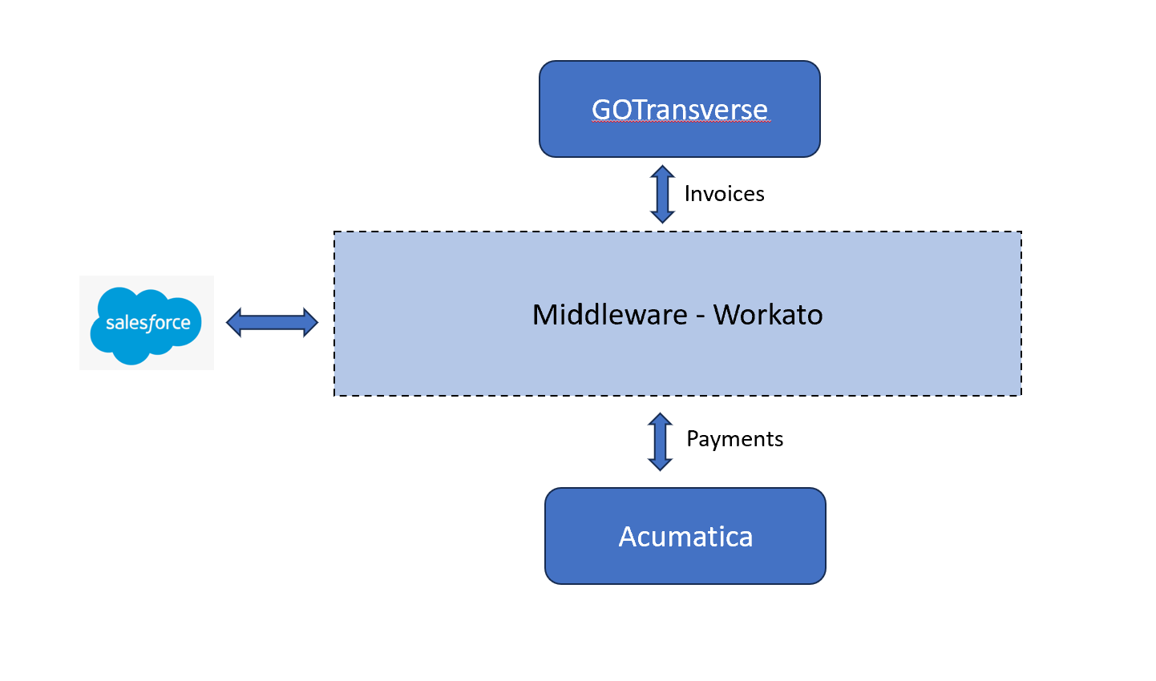 Figure 1. All interfaces route through Workato between GoTransvers and Acumatica

Agreed Position and Source Differences
Topic | Position | State
Integration layer | All interfaces route through Workato, including Salesforce to GT. GT's invoice pushed to Acumatica through middleware Workato, which posts to Acumatica.  Acumatica will push the payment details back to GT through middleware Workato. | Decided
Payment path | Workato takes events from Acumatica and delivers to GT. | Decided
Invoice trigger | Call: scheduled, not event-driven. GT document: real-time or scheduled still an open item. | Scheduled; interval
Payment status in Salesforce | Payments from Acumatica automatically persist payment status up to Salesforce.  Earlier design position: GT does not return payments to Salesforce. | Open
GL | No separate GL feed. GL account and subaccount travel on each invoice line; Acumatica creates the entries. | Agreed
Master data | Salesforce maintains customer and GL accounting information and syncs to GT and Acumatica; no GT to Acumatica master sync. | Agreed
Credit memos | Call: same path as invoices. GT document: separate credit memo integration, not yet designed. Credits originate in Salesforce and are posted by GT. | Confirm design (Q8)
Prepayments, attachments | No prepayment requirement known. No PDF or CSV sent to Acumatica. | Agreed

Role of Workato and Boundaries
Topic | Design position
What Workato does | Receives, validates, transforms, routes and monitors messages between systems. Holds only transient data and a small log of message identifiers and statuses.
What Workato does not do | It does not own master data, invoices, payments or any patient data, and does not calculate tax, rates or GL postings. It does not create master records when one is missing.
Payments (Acumatica to GT) | In scope and treated as decided: Workato is the middle layer (GTA-C04, decision D2).
Invoices (GT to Acumatica) | In scope and decided: GT delivers each approved invoice to Workato, which posts it to Acumatica in Balanced status and then releases it (R2). No transformation: GT sends the Acumatica-shaped payload. GT's design v2.3 calls Acumatica directly and must be updated; GT has said the pivot is possible.
Who builds what | Durvah builds the Workato work for GT to Acumatica invoices, release, and Acumatica to GT payments, and the PHI tokenization on orders. Ascent builds the Ascent to GT and GT to Ascent interfaces (orders, credit memos, invoices). Because those also route through Workato, who builds those recipes is open (W11).
Masters (Salesforce to Acumatica) | Customer and GL accounting data are mastered in Salesforce and synced to both GT and Acumatica. The Acumatica leg is a Workato recipe (R3). Scope of objects to confirm.

Recipe Catalog
Recipe | Purpose | Trigger | Source | Target
R1 Payments to GT | Deliver Acumatica payments and applications to GT | Nightly scheduled pull | Acumatica | GT Create Payment API (or file drop)
R2 Invoices to Acumatica | Relay an approved GT invoice to Acumatica as Balanced, release it, and return the status | GT pushes on billing approval | GT | Acumatica Invoice entity
R3 Exception replay | Reprocess parked messages after the cause is fixed | Manual action or schedule | Exception queue | R1, R2 or R3
R4 Health and reconciliation | Daily check of counts and open balances; alert on gaps | Scheduled | GT and Acumatica | Support alert, report

Payments from Acumatica to GT
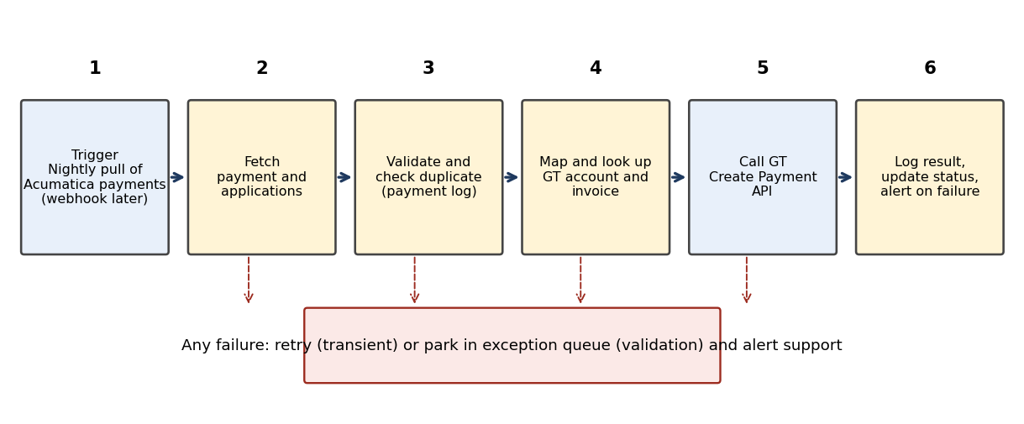
Figure 2. Payment recipe flow (R1).

Behavior
ID | Requirement | Pri | Acceptance criteria
WKT-101 | R1 shall run once each and pull the day's payments from Acumatica's payment GET API. The pull time is set with Finance (for example between 10 pm and midnight). | M | Chosen option runs end to end in test
WKT-102 | R1 shall retrieve the full payment with its API from Acumatica, because the trigger may carry only a key. The Acumatica Payment entity are read through the Acumatica REST API. | M | Payment with 3 applications fetched completely
WKT-103 | R1 shall ignore payments that are not for GT-billed invoices, voided or unreleased, and shall treat a reversal as a separate message type (rules in Q11 of the FRS). | M | Non-GT payment skipped and logged
WKT-104 | R1 shall check the payment log before sending. A payment ID already marked Delivered shall not be sent again (GTA-C06). | M | Replay test creates no second payment
WKT-105 | R1 shall carry at least the fields: account ID, account number, email, payment date, payment amount, invoice ID, invoice number, application amount and timestamp. GT's Create Payment API itself needs the account, payment amount, invoice, application amount and Occurs On. | M | Request passes GT validation
WKT-106 | R1 shall resolve the GT invoice by the invoice number held in Acumatica and the GT account by the Customer ID, which equals GT's external account number (DM-001). Resolution uses a GT lookup call, cached in a Workato lookup table where useful. | M | All test payments find their invoice
WKT-107 | R1 shall reject to the exception queue, without calling GT, a payment whose invoice or account cannot be resolved, or whose applications exceed the payment amount or the open balance (GTA-C05). | M | Exception carries reason code
WKT-108 | After GT responds, R1 shall write the result (Delivered, Failed, Parked), GT payment reference and time to the payment log, and where useful write status back to Acumatica. Delivery status shall be visible to support (GTA-F03). | M | Log row per payment
WKT-109 | Payment status and balance to Ascent and the portal are Phase 2 (D6 closed for go-live). When built, R1 shall publish the result to Salesforce or Ascent as an account-level update, with no PHI and no financial calculations. | C | Phase 2 item recorded

Payment field mapping
GT element | Acumatica source | Rule
Account ID or Number | Payment: Customer (Customer ID) | Equals GT external account number; resolved to GT account ID if the API needs the ID.
Payment Amount | Payment: payment amount | Total of the payment. Currency USD.
Invoice ID or Number | Applied document: reference number or customer order value | GT invoice number; one of ID or Number is enough.
Application Amount | Applied document: amount paid | One application per invoice; sum equals payment amount unless an unapplied balance remains (Q11).
Occurs On | Payment: application or release date | Timestamp in the format GT expects.
Payment identifier (for duplicate check) | Payment: reference number and type | Kept in the payment log; sent to GT if the API accepts an external ID. [Validate]

Acumatica field names above are the standard names of the Payment entity and may differ on USME's custom endpoint; confirm against the endpoint definition

\

R2. Invoices from GT to Acumatica
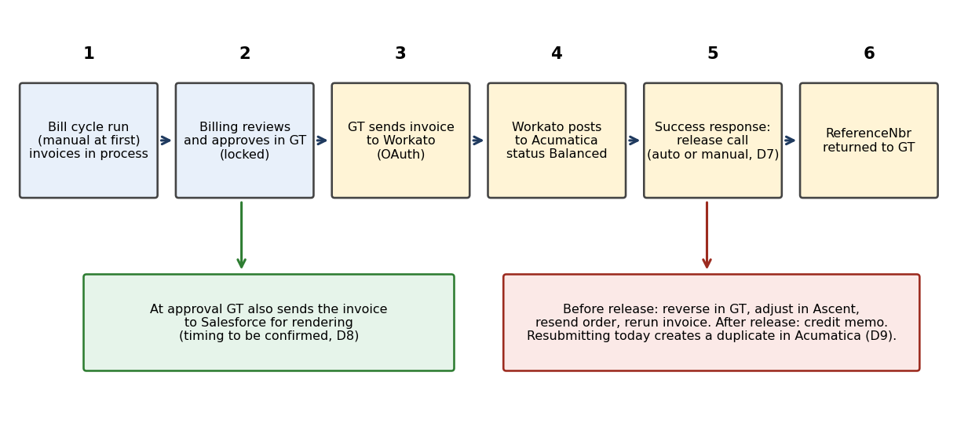
Figure 3. Invoice flow agreed on Oct 27: approve, post as Balanced, release.
ID | Requirement | Pri | Acceptance criteria
WKT-201 | GT shall deliver each approved invoice to Workato (one message per invoice, with header and aggregated lines in the structure of the GTA field mapping tables), and R2 shall post it to Acumatica's AR Invoice entity. GT's configurable payload mapping means the Acumatica-shaped JSON can be produced in GT, leaving Workato to route, authenticate and monitor. | M | Invoice reaches Acumatica via Workato
WKT-202 | R2 shall not change amounts, accounts or lines. It may only validate required fields, check the master values exist (customer, inventory ID, account, subaccount) and wrap the message. No tax or aggregation logic lives in Workato. | M | Payload in equals payload out
WKT-203 | R2 shall start when GT sends an approved, process invoices in the order received, and use the invoice number as the idempotency key. GT calls an endpoint in Workato secured by OAuth; Workato issues the client credentials and registers GT as an external application. Workato's HTTP connector is used for calls to GT, since there is no ready-made GT connector. [Validate] | M | GT call accepted; duplicate send test
WKT-204 | R2 shall return to GT, per invoice, the response status, error text and the Acumatica ReferenceNbr on success (GTA-B09), using GT's API or a GT status field. | M | GT shows the reference
WKT-205 | R2 shall apply the response rules in GTA-B10: 400 to the exception queue without blind retry; 401 re-authenticate once then escalate; 404 alert; timeout and 5xx retry with back-off. | M | Each case demonstrated
WKT-206 | Whether Acumatica posts one GL transaction per invoice or per line, and whether any accumulation happens in Workato, shall follow D4. The default is no accumulation in Workato. | M | D4 recorded
WKT-208 | R2 shall post each invoice to Acumatica in Balanced status (Hold false), because Acumatica cannot receive an invoice already final. | M | Invoice shows Balanced in Acumatica
WKT-209 | After a success response, R2 shall call Acumatica's release action for that invoice if the business confirms automation (D7). If not, R2 stops at Balanced and billing releases by hand. A failed release shall go to the exception queue, and the invoice shall not be reported to GT as final until released. Release is final; later changes need a credit memo. | M | Released status confirmed in test
WKT-210 | Before posting, R2 shall check whether an invoice with the same CustomerOrder number already exists in Acumatica. If an unreleased one exists, R2 shall apply the D9 rule (update it, cancel it, or alert billing); it shall never leave two open invoices without an alert. The default until D9 is decided is to alert billing and not post. | M | Reversed and resent invoice test
WKT-211 | Credit invoices (RCR, SCR) shall use R2 unchanged if the credit memo design confirms the same path (Q8); otherwise a separate recipe is specified later. | S | Credit sample accepted

R3 and R4. Exceptions, replay and reconciliation
ID | Requirement | Pri | Acceptance criteria
WKT-401 | Every failed or parked message shall create one row in the exception queue (a Workato data table) with: recipe, message key, time, error class, error text, payload reference and status (Open, Replayed, Closed). | M | Row created for each failure type
WKT-402 | Errors shall be classed as transient (retry automatically with back-off, up to a set count), data (park until corrected) and configuration (alert immediately). | M | Class assigned in test
WKT-403 | Support shall be able to replay a parked message from the exception queue once the cause is fixed. Replay shall use the same idempotency key. Replays shall be logged with the user. | M | Replay audit row
WKT-404 | Each failure shall alert the named support group by email and the team channel with recipe, key and reason. Repeated failures of the same type shall be grouped into one alert. | M | Alert received
WKT-501 | R5 shall run daily and compare counts and amounts: invoices finalized in GT versus received in Acumatica, and payments released in Acumatica versus applied in GT, and report differences to Finance and support. | S | Report shows a seeded mismatch

Security and Operations
ID | Requirement | Pri | Acceptance criteria
WKT-601 | Connections: Acumatica (OAuth2), GT (API credentials), Salesforce (OAuth), SFTP or S3 if option 2. Credentials shall live only in Workato connections, never in recipe steps, with separate connections per environment. | M | Review of connections list
WKT-602 | Workato shall not store PHI. Payloads carry customer reference, invoice numbers and amounts only. Logging shall exclude any free text from source systems. [Validate] | M | Log sample checked
WKT-603 | Environments: Dev, Test and Production workspaces (or folders) with the same recipe names; recipes move by Workato's recipe lifecycle management or export and import, with configuration held in properties, not recipe edits. | M | Promotion run through all three
WKT-604 | Roles: developers edit in Dev only; production edits require a change record; support has monitor and replay rights; Finance has read access to reports. | M | Role matrix approved
WKT-605 | Naming and folders: one folder per integration (Acumatica-GT, Acumatica-SFDC), recipes prefixed R1 to R5, connections suffixed with environment. | S | Standards applied
WKT-606 | Volume: about 6,735 invoices a month and a payment volume still to be confirmed. The design shall run inside Workato task limits of the USME plan; the plan limit shall be checked against monthly task use (each recipe step is a task). [Validate] | M | Task estimate approved
WKT-607 | Availability: retries and the stored watermark shall let all recipes recover from a Workato or Acumatica outage without loss or duplicates. | M | Outage test

Test Scenarios
Test | Recipe | Expected
Payment applied to one invoice | R1 | GT invoice balance reduced; log row Delivered
Payment across three invoices | R1 | Three payment amounts as sent
Same payment sent twice | R1 | Second skipped or updated
Unknown invoice or over-application | R1 | Parked with reason; no GT call
Reversal or void | R1 | Handled per Q11 rule
Invoice with mixed taxable and $0 lines | R2 | Accepted; reference returned
Invoice posted, then released | R2 | Balanced, then Released; reference returned
Release call fails | R2 | Parked; GT not told final
Invoice reversed in GT and resent before release | R2 | One open invoice, or an alert per D9
Nightly payment pull | R1 | Day's payments applied in GT; second run skips them
400, 401, 404, 5xx from Acumatica | R2 | Each handled per WKT-205
New customer in Salesforce | R3 | Appears in Acumatica with matching ID
Transaction before its customer exists | R3, R4 | Parked, then released
Acumatica outage for one hour | All | No loss, no duplicates on recovery

Dependencies and Next Steps
Item | Owner
Confirm Acumatica endpoint, OAuth2 credentials and whether it can raise payment events (Mike Venkata is checking webhooks) | USME IT, Acumatica team
Register GT as an external application in Workato and share OAuth credentials | RaviTeja Bommareddy
Workato dev access for Ravi (Rootstock provisions; Eric Tyler escalating) and Acumatica lower-environment access (Eric Tyler to Clint) | USME IT, Rootstock
Payment pull endpoint prepared and reviewed; GT invoice test data end of this week or early next | Mike Venkata, GT
Confirm release automation (D7) with billing, and deep-dive on invoice corrections (D9) | Shery Zachariah
Obtain GT Create Payment API contract, authentication and error behavior | GT
Workato tenant, workspaces, connection access and SME resource for this build | Durvah, USME IT
Confirm how masters will be integrated | USME IT
Task and plan check for monthly volume | Durvah, Workato

